First Presbyterian Church

104 So. 10th St., Norfolk, NE 68701
Phone: 402-371-1635

January 4, 2026



Mission Statement

Proclaiming the Love of Christ
in the Heart of Norfolk
Since 1896
Order of Worship
Sunday Worship, January 4, 2026
Second Sunday of Christmas
First PC, Norfolk, NE

Leader: The grace of the Lord Jesus Christ be with you all.
People: And also with you.

Welcome and Announcements

Passing of the Peace
Leader: The peace of the Lord Jesus Christ be with you all!
People: And also with you.

Let us share signs of Christ’s peace with one another

Call to Worship
Leader: Extol the Lord, O Jerusalem;
People: praise your God, O Zion,
Leader: for he strengthens the bars of your gates
People: and blesses your people within you.
Leader: He grants peace to your borders
People: and satisfies you with the finest of wheat.
Leader: He sends his command to the earth;
People: his word runs swiftly.
-- Psalm 147:12-15

Opening Song (24) (Cradle) “Away in a Manger”
Call to Confession
Remember that our Lord Jesus can sympathize with us in our weaknesses, since in every respect he was tempted as we are, yet without sin. Let us then with boldness approach the throne of grace, that we may receive mercy and find grace to help in time of need. Let us confess our sins against God and our neighbor.

Prayer of Confession

God of grace and truth, in Jesus Christ you came among us as light shining in darkness. We confess that we have not welcomed the light, or trusted good news to be good. We have closed our eyes to glory in our midst, expecting little, and hoping for less. Forgive our doubt, and renew our hope, so that we may receive the fullness of your grace, and live in the truth of Christ the Lord.

(We observe a time of silence for personal confession.)

Assurance of Pardon

Leader: Friends, hear the Good News! The liberator has
come to free us from all pretenses.
People: The Christ has come in Jesus of Nazareth to
show us the undeserved favor of God.
Leader: Friends, believe the Good News!
People: In Jesus Christ, we are forgiven.

Response (579) “Glory to the Father (Gloria Patri)”

The Word

Children’s Message
Scripture John 1:1-18
Message “God’s Pure Light” Pastor Brian

Carol (29) “Go, Tell It on the Mountain”

Offering our Gifts

Offertory
Response (592) “Praise God, from Whom All Blessings Flow”
(Doxology)

Song of Preparation (insert)
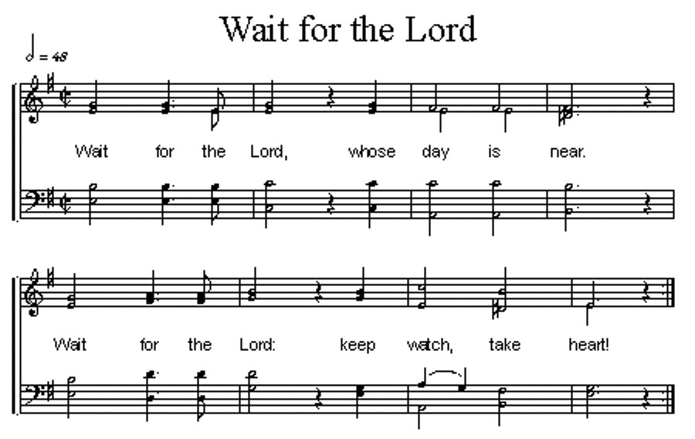

Prayers of the People/Lord’s Prayer

Our Father who art in heaven, hallowed be thy name.
Thy Kingdom come, thy will be done, on earth as it is in heaven.
Give us this day our daily bread;
and forgive us our debts, as we forgive our debtors;
and lead us not into temptation, but deliver us from evil.
For thine is the kingdom, and the power and the glory, forever. Amen

Hymn (66) “We Three Kings of Orient Are”

Communion
Invitation to the Table
Words of Institution
Sharing the Sacrament
Prayer

Blessing and Sending

Postlude

We are glad you chose to spend your Sunday morning with us, and we encourage you to return!

Children of all ages are welcome in worship. Children’s worship materials are available from the book cart. A Cry Room is located at the back of the sanctuary.

Next Sunday, 1/11/26, First Presbyterian Church will have ordination & installation of Elders and Deacons.

The Deacon’s Mission Giving Project for January is Nebraska Children’s Home Society (NCHS). It is a statewide private, licensed non-profit agency focused on providing safe and loving care to children of all ages.

Birthdays

Xavier Kaps 1/04
Linda Beckenhauer 1/07
Dave Unkel 1/10
Al Beckmann 1/15
Tyler Wells 1/17

Anniversaries

Ed & Renée McClymont 1/08
Dave & Linda Unkel 1/13

Prayers for God’s Children

For healing and pain relief for those living with physical and emotional pain and for their families and friends
For our members who are home-bound or in nursing facilities
For our mission partners
For the men and women serving in our armed force

This Week at First Pres
Today: 10:00 AM – Worship
7:00 PM – 10:00 PM N/A (fellowship hall)
Monday: 8:30 AM – 10:30 AM N/A (fellowship hall)
7:00 PM – Deacons
Tuesday: 8:00 PM – 9:30 PM N/A (fellowship hall)
Wednesday: 2:00 PM – Bulletin Information Deadline
6:45 PM – Choir Rehearsal
Saturday: 8:30 AM – 10:00 AM The Link
Next Sunday
10:00 AM – Worship
10:00 AM – Good Morning, Good News

Elders Deacons
Class of 2025 Class of 2025
Teri Wendel, Christian Ed. Shelley Dahl, Secretary
Dave Gerharter, Finance Sonja Jones, Co-Moderator
Pat McCollough, Properties Mary Osborne, Co-Moderator
Class of 2026 Class of 2026
Dennis Sateren, Missions Doug Kuper
Barb Beckmann Worship/Cong. Kathy Sateren
Erin Beckenhauer, Worship/Cong.
Class of 2027 Class of 2027
Marci Pierce, Personnel Sherry Johnson, Treasurer
Sue May
Dave Unkel

Renée McClymont, Clerk of Session, Class of 2026

Elders of the Month – Renée McClymont & Marci Pierce

2025 YTD Financials – through November 30th, 2025
Receipts $188,066.18 – Disbursements $223,035.36 = Net <$34,969.18>
Last Sunday Attendance 18

Worship Leaders & Staff

PASTOR Rev. Brian Johnson
MUSIC DIRECTOR Greta Johnson ORGANIST Steve Reinke
SOUND TEAM Joe Mtika, Barb Beckmann, Jeff May
PRAISE TEAM Kim Rusk, Brynn Rusk, Joe Mtika
LAY READER Marci Pierce

Office hours: 9 am to 1 pm Mon.
9 am to 4 pm Tues. – Thur.
9 am to 1 pm Fri.
or other times by appointment

E-Mail: Karen@firstpresnorfolk.com
Website: firstpresnorfolk.com



