First Presbyterian Church

104 So. 10th St., Norfolk, NE 68701
Phone: 402-371-1635

August 2, 2026



Mission Statement

Proclaiming the Love of Christ
in the Heart of Norfolk
Since 1896

Order of Worship
Sunday Worship, August 2, 2026
Eleventh Sunday After Pentecost
First PC, Norfolk, NE

Prelude

Leader: The grace of the Lord Jesus Christ be with you!
People: And also with you!

Welcome and Announcements

Passing of the Peace

Leader: The peace of the Lord Jesus Christ be with you all!
People: And also with you.
Leader: Let us share signs of Christ’s peace with one
another.

Call to Worship

Leader: O give thanks to God and call on God’s name,
People: Proclaim the deeds of the Lord to all the
peoples.
Leader: Sing to the Lord, sing praises to God.
People: Tell of all God’s wonderful works.
Leader: Glory in God’s holy name;
People: Seek the presence of the Lord, rejoicing with all your heart.
All: Let us worship God together. Amen.

Opening Hymn (358) “Help Us Accept Each Other”

Call to Confession

Remember that our Lord Jesus can sympathize with us in our weaknesses, since in every respect he was tempted as we are, yet without sin. Let us then with boldness approach the throne of grace, that we may receive mercy and find grace to help in time of need. Let us confess our sins against God and our neighbor.

Prayer of Confession

It seems so easy to get into the boat and set sail on our journey, God of Promises. But when the winds of change begin to blow, we want to turn around and head back to the past's safe harbor. When sin's waves crash over the side, we try to wrap ourselves in the cloak of pride thinking we will not get wet. When Jesus calls to us to get out and follow in faith, we look around, hoping he is not speaking to us. Swamped by our fears, and sinking in doubt, we long for someone to help us - so save us, Holy One, save us! Stretch out your hand, so we might be lifted from our despair to hope, from our worries to trust, from our foolishness to faithful living. Then, we will dare to follow Jesus Christ, our Lord and Savior, even if it means getting out of the sheltered lives we have built for ourselves. Amen.

(We observe a time of silence for personal confession.)

Assurance of Pardon

Leader: In confessing that Christ is Lord, we let go of the past, and turn to God's future. We step out of our fears, and walk into the light and life offered by our God.
People: In trusting Christ's resurrection, we trust all of God's promises, letting the Spirit work in and through us, healing and making us whole. Thanks be to God, we are forgiven! Amen.

Response (579) “Glory to the Father (Gloria Patri)”

Special “You’ll Never Walk Alone”
ASL, Sherry Johnson

The Word

Scripture Genesis 37:1-4,12-28. Matthew 14:22-33
Message “What Dreams Can Do”
Rev. Kathleen Splitt

Song of Response (417)
“Christ Is Made the Sure Foundation”

Offering our Gifts

Response (592) “Praise God, from Whom All Blessings Flow”
(Doxology)

Song of Preparation
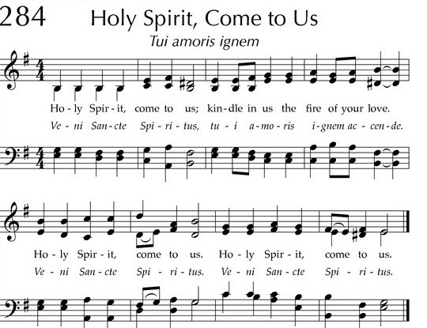
Prayers of the People/Lord’s Prayer

Our Father who art in heaven, hallowed be thy name.
Thy Kingdom come, thy will be done, on earth as it is in heaven.
Give us this day our daily bread;
and forgive us our debts, as we forgive our debtors;
and lead us not into temptation, but deliver us from evil.
For thine is the kingdom, and the power and the glory, forever. Amen

Final Hymn (339) “Be Thou My Vision”

Blessing and Sending

Postlude

We are glad you chose to spend your Sunday morning with us, and we encourage you to return!

Children of all ages are welcome in worship. Children’s worship materials are available from the book cart. A Cry Room is located at the back of the sanctuary

We welcome Rev. Kathleen Splitt to the pulpit today.

Looking forward . . . Missionary, Don Heckmann, will be with First Presbyterian on August 30th.

The Deacon’s Mission Giving Project for August is The Zone. The Zone is a proactive community-based afterschool program targeting 7th-12th graders. The mission is to promote the physical, mental, emotional, social, and spiritual well-being of adolescents. The afterschool program provides a safe environment that strengthens social skills and character.
Construction Update . . . Until further notice, access to the Education Wing will be restricted. If you need anything in the Education Wing, please contact Erin Beckenhauer, (402) 669-0195 or Renée McClymont, (402)750-0180).
The Fellowship Hall will be closed Mon-Fri, 8am-5pm due to construction.

Birthdays

Sandra Chisesele 8/12
Ryan Praeuner 8/12
Teddy Tillman 8/18

Anniversaries

None this week

Prayers for God’s Children

For healing and pain relief for those living with physical and emotional pain and for their families and friends
For our members who are home-bound or in nursing facilities
For our mission partners
For the men and women serving in our armed forces

This Week at First Pres

Today: 10:00 AM – Worship
Monday: 8:30 AM – 10:30 AM N/A (fellowship hall)
Tuesday: 8:00 PM – 9:30 PM N/A (fellowship hall)
Wednesday: 2:00 PM – Bulletin Information Deadline
Friday 11:00 AM – 1:00 PM The Zone/Youth Room
Saturday: 8:30 AM – 10:00 AM The Link

Next Sunday

10:00 AM – Worship

Elders Deacons
Class of 2026 Class of 2026
Dennis Sateren, Missions Doug Kuper
Barb Beckmann, Worship/Cong. Kathy Sateren
Erin Beckenhauer, Worship/Cong.
Class of 2027 Class of 2027
Marci Pierce, Personnel Sherry Johnson, Treasurer
Jake Cox Sue May
Dave Unkel, Co-Moderator
Class of 2028 Class of 2028
Jeff May, Finance Dave Gerharter
Don Burns, Properties Sonja Jones, Co-Moderator
Kerry Richter, Christian Ed Kim Rusk, Secretary

Renée McClymont, Clerk of Session, Class of 2026

Elders of the Month – Barb Beckmann & Jeff May

2026 YTD Financials – through June 30th, 2026
Receipts $98,585.70 – Disbursements $112,877.71 = Net <$14,292.01>
Last Sunday Attendance 59

PASTOR Rev. Brian Johnson
MUSIC DIRECTOR Greta Johnson ORGANIST Steve Reinke
SOUND TEAM Joe Mtika, Barb Beckmann, Jeff May
PRAISE TEAM Katie Tillman, Addy Rusk, Brynn Rusk
LAY READER Renée McClymont
Office hours: 9 am to 1 pm Mon.
9 am to 4 pm Tues. – Thur.
9 am to 1 pm Fri.
or other times by appointment
Worship Leaders & Staff

E-Mail: Karen@firstpresnorfolk.com
Website: firstpresnorfolk.com



