First Presbyterian Church

104 So. 10th St., Norfolk, NE 68701
Phone: 402-371-1635

February 1, 2026



Mission Statement

Proclaiming the Love of Christ
in the Heart of Norfolk
Since 1896
Order of Worship
Sunday Worship, February 1, 2026
Fourth Sunday after Epiphany
First PC, Norfolk, NE

Leader: The grace of the Lord Jesus Christ be with you all.
People: And also with you.

Welcome and Announcements

Passing of the Peace
Leader: The peace of the Lord Jesus Christ be with you all!
People: And also with you.

Let us share signs of Christ’s peace with one another

Call to Worship

Leader: Lord, who may dwell in your sanctuary? Who may
live on your holy hill?
People: He whose walk is blameless and who does
what is righteous,
Leader: who speaks the truth from his heart and has no
slander on his tongue,
People: who does his neighbor no wrong and casts no
slur on his fellowman,
Leader: who despises a vile man but honors those who fear
the Lord,
People: who keeps his oath even when it hurts,
Leader: who lends his money without usury, and does not
accept a bribe against the innocent.
People: He who does these things will never be shaken.
-- Psalm 15:1-5

Opening Song (led by Praise Band)
“10,000 Reasons (Bless the Lord)”

Call to Confession

If we say we have no sin, we deceive ourselves, and the truth is not in us. But if we confess our sins, God who is faithful and just will forgive us our sins and cleanse us from all unrighteousness. In humility and faith, let us confess our sin to God.

Prayer of Confession

God of glory, you sent Jesus among us as the light of the world, to reveal your love for all people. We confess that our sin and pride hide the brightness of your light. We turn away from the poor; we ignore cries for justice; we do not strive for peace. In your mercy, cleanse us of our sin, and baptize us once again with your Spirit, that, forgiven and renewed, we may show forth your glory shining in the face of Jesus Christ.

(We observe a time of silence for personal confession.)

Assurance of Pardon

Leader: Friends, hear the Good News! God has made Christ
our wisdom and righteousness.
People: In him we are consecrated and free.
Leader: Friends, believe the Good News!
People: In Jesus Christ, we are forgiven.

Response (579) “Glory to the Father (Gloria Patri)”

Choir Anthem “Come, Share the Lord”

The Word

Children’s Message
Scripture 1 Corinthians 1:18-31
Message “Peace is Wisdom” Pastor Brian

Song of Response (417)
“Christ is Made the Sure Foundation”

Offering our Gifts

Offertory

Response (592) “Praise God, from Whom All Blessings Flow”
(Doxology)

Song of Preparation (insert)
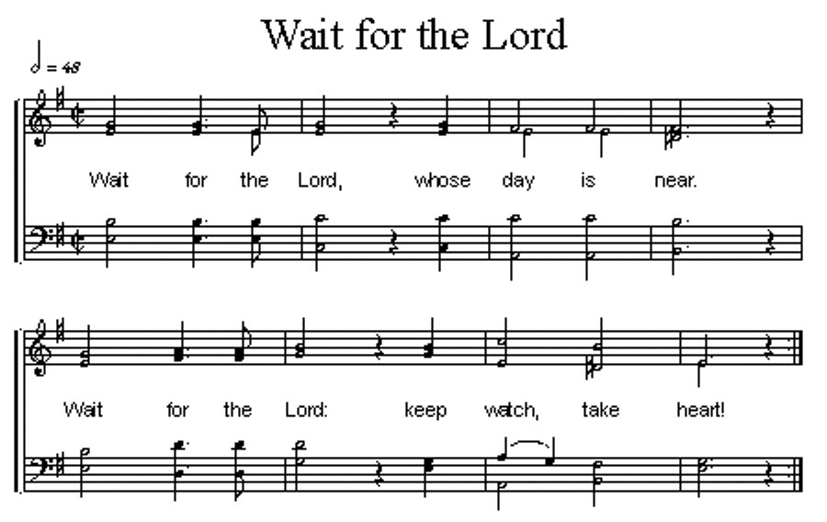

Prayers of the People/Lord’s Prayer

Our Father who art in heaven, hallowed be thy name.
Thy Kingdom come, thy will be done, on earth as it is in heaven.
Give us this day our daily bread;
and forgive us our debts, as we forgive our debtors;
and lead us not into temptation, but deliver us from evil.
For thine is the kingdom, and the power and the glory, forever. Amen

Communion
Invitation to the Table
Words of Institution
Sharing the Sacrament (with 513 – “Let Us Break
Bread Together”)
Prayer

Blessing and Sending

Postlude

We are glad you chose to spend your Sunday morning with us, and we encourage you to return!

Children of all ages are welcome in worship. Children’s worship materials are available from the book cart. A Cry Room is located at the back of the sanctuary

Our Lenten Study for this year is “Celebration of Discipline” by Richard J. Foster. Study will begin on Tuesday, Feb. 24th at 6:30pm. A sign-up sheet is in the narthex..

The Per Capita for First Presbyterian Church is $38.96 per person for 2026.
Annual Congregational Meeting, Feb. 8, 2026. Please plan to join us after worship service for a ‘picnic’ lunch in the Fellowship Hall in the church basement. We will serve sloppy jo sandwiches, baked beans, chips & dessert. If you would like to contribute a salad, pickles or a dessert, please add that to the sign-up sheet (in narthex).

The Deacons Project for February is Norfolk Rescue Mission. Since 1996, the Norfolk Rescue Mission has provided a safe haven for people who are hurting, homeless or in need of a friend. The Mission provides not only assistance with food and shelter, but it also helps those staying at its facilities to become responsible, contributing members of the church and society.

Birthdays

Dennis Sateren 2/02
Katie Tillman 2/02
Patricia McCollough 2/04
Kim Rusk 2/05
Barb Beckmann 2/06
Sarah Peterson 2/06
Nancy Praeuner 2/07
Lucas Praeuner 2/07
Dave Unkel 2/10

Anniversaries
None this week

Prayers for God’s Children

For healing and pain relief for those living with physical and emotional pain and for their families and friends
For our members who are home-bound or in nursing facilities
For our mission partners
For the men and women serving in our armed force

This Week at First Pres
Today: 10:00 AM – Worship
7:00 PM – 10:00 PM N/A (fellowship hall)
Monday: 8:30 AM – 10:30 AM N/A (fellowship hall)
6:30 PM – Session
Tuesday: 8:00 PM – 9:30 PM N/A (fellowship hall)
Wednesday: 2:00 PM – Bulletin Information Deadline
6:45 PM – Choir Rehearsal
Saturday: 8:30 AM – 10:00 AM The Link

Next Sunday
10:00 AM – Worship

Elders Deacons
Class of 2026 Class of 2026
Dennis Sateren, Missions Doug Kuper
Barb Beckmann, Worship/Cong. Kathy Sateren
Erin Beckenhauer, Worship/Cong.
Class of 2027 Class of 2027
Marci Pierce, Personnel Sherry Johnson, Treasurer
Jake Cox, Properties Sue May
Dave Unkel, Co-Moderator
Class of 2028 Class of 2028
Jeff May Dave Gerharter
Don Burns Sonja Jones, Co-Moderator
Kerry Richter, Christian Ed Kim Rusk

Renée McClymont, Clerk of Session, Class of 2026

Elders of the Month – Renée McClymont & Barb Beckmann

2025 YTD Financials – through December 31st, 2025
Receipts $217,240.28 – Disbursements $256,721.26 = Net <$39,480.98>
Last Sunday Attendance 44

Worship Leaders & Staff

PASTOR Rev. Brian Johnson
MUSIC DIRECTOR Greta Johnson ORGANIST Steve Reinke
SOUND TEAM Joe Mtika, Barb Beckmann, Jeff May
PRAISE TEAM Kim Rusk, Brynn Rusk, Joe Mtika
LAY READER Shelley Dahl

Office hours: 9 am to 1 pm Mon.
9 am to 4 pm Tues. – Thur.
9 am to 1 pm Fri.
or other times by appointment

E-Mail: Karen@firstpresnorfolk.com
Website: firstpresnorfolk.com

