First Presbyterian Church

104 So. 10th St., Norfolk, NE 68701
Phone: 402-371-1635

May 31, 2026



Mission Statement

Proclaiming the Love of Christ
in the Heart of Norfolk
Since 1896

Order of Worship
Sunday Worship, May 31, 2026
Trinity Sunday
First PC, Norfolk, NE

Prelude

Leader: The grace of the Lord Jesus Christ be with you!
People: And also with you.

Welcome and Announcements

Passing of the Peace

Leader: The peace of the Lord Jesus Christ be with you all!
People: And also with you.
Leader: Let us greet one another in Christ’s peace.

Call to Worship
Leader: O Lord, our Lord, how majestic is your name in all
the earth!
People: You have set your glory above the heavens.
Leader: From the lips of children and infants you have
ordained praise because of your enemies,
People: to silence the foe and the avenger.
Leader: When I consider your heavens, the work of your
fingers, the moon and the stars, which you have set in place,
People: what are people that you are mindful of them,
human beings that you care for them?
Leader: Yet you made them a little lower than the angels
and crowned them with glory and honor.
People: You made them rulers over the works of your
hands, putting everything under their feet – all flocks and herds, and the beasts of the field;
Leader: the birds of the air, and the fish of the sea; all that
swim the paths of the seas.
All: O Lord, our Lord, how majestic is your name in
all the earth!
-- Psalm 8:1-9
Opening Hymn (138)
“Holy, Holy, Holy! Lord God Almighty”

Call to Confession

As the hymn says, it is the Christian affirmation that the One God is present to us in 3 persons – Father, Son, and Holy Spirit. However paradoxical that is, this idea of Trinity expresses to us that God lives in divine community. We are called to live that way, but fall short. For the times we have failed to live in community with God and with our fellow humans, we look for forgiveness as we confess our sins to God.

Prayer of Confession

God of grace, love, and communion, we confess that we have failed to love you with all our heart, soul, and mind; and to love our neighbor as ourselves. We ignore your commandments, stray from your way, and follow other gods. Have mercy on us. Forgive our sin and raise us to new life that we may serve you faithfully and give honor to your holy name.

(We observe a time of silence for personal confession.)

Assurance of Pardon
Leader: Friends, hear the good news! The Lord will give
strength to his people.
People: The Lord will bless his people with peace.
Leader: Friends, believe the good news!
People: In Jesus Christ, we are forgiven.
Response (579) “Glory to the Father (Gloria Patri)”

Special Music Greta Johnson

The Word

Scripture Matthew 28:16-20
Message “Go, Therefore” Pastor Brian

Song of Response (video) “How Great Is Our God”

Offering our Gifts

Offertory

Response (592) “Praise God, from Whom All Blessings Flow”
(Doxology)

Song of Preparation

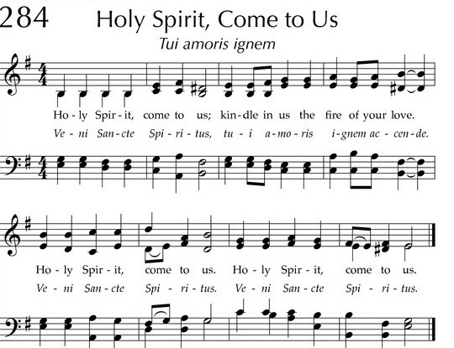

Prayers of the People/Lord’s Prayer

Our Father who art in heaven, hallowed be thy name.
Thy Kingdom come, thy will be done, on earth as it is in heaven.
Give us this day our daily bread;
and forgive us our debts, as we forgive our debtors;
and lead us not into temptation, but deliver us from evil.
For thine is the kingdom, and the power and the glory, forever. Amen

Final Song (140) “Holy, Holy”

Blessing and Sending

Postlude

We are glad you chose to spend your Sunday morning with us, and we encourage you to return!

Children of all ages are welcome in worship. Children’s worship materials are available from the book cart. A Cry Room is located at the back of the sanctuary

Construction Update . . . Until further notice, access to the Education Wing will be restricted. If you need anything in the Education Wing, please contact Erin Beckenhauer, (402) 669-0195 or Renée McClymont, (402)750-0180).
The Fellowship Hall will be closed Mon-Fri, 8am-5pm due to construction.

The Deacon’s Mission for May is S.M.I.L.E., which stands for “Stephanie’s Miracles in Loving Equine”. The program began in 1992 and is a program pairing horses with special needs children. Located between Battle Creek and Madison it serves about 125 students during the summer months. Kids are taught not only riding skills, but also how to care
for and love the animals.

Birthdays

Warren Reimer 5/31
Wayne Smith 6/01
Alex Hardisty 6/09
Cody Wells 6/10
Joe Beckenhauer 6/11
Brynn Rusk 6/12
Addy Rusk 6/12

Anniversaries

Joe & Jayne Mtika 6/03
James & Faye Simpson 6/07
Norm & Marj Winder 6/07
Jake & Linda Cox 6/09
Andrew & Nancy Praeuner 6/13

Prayers for God’s Children

For healing and pain relief for those living with physical and emotional pain and for their families and friends
For our members who are home-bound or in nursing facilities
For our mission partners
For the men and women serving in our armed forces

This Week at First Pres

Today: 10:00 AM – Worship
Monday: 8:30 AM – 10:30 AM N/A (fellowship hall)
6:30 PM – Session
Tuesday: 8:00 PM – 9:30 PM N/A (fellowship hall)
Wednesday: 2:00 PM – Bulletin Information Deadline
Friday 4:00 PM – 5:30 PM The Zone/Youth Room
Saturday: 8:30 AM – 10:00 AM The Link

Next Sunday
10:00 AM – Worship
Elders Deacons
Class of 2026 Class of 2026
Dennis Sateren, Missions Doug Kuper
Barb Beckmann, Worship/Cong. Kathy Sateren
Erin Beckenhauer, Worship/Cong.
Class of 2027 Class of 2027
Marci Pierce, Personnel Sherry Johnson, Treasurer
Jake Cox Sue May
Dave Unkel, Co-Moderator
Class of 2028 Class of 2028
Jeff May, Finance Dave Gerharter
Don Burns, Properties Sonja Jones, Co-Moderator
Kerry Richter, Christian Ed Kim Rusk, Secretary

Renée McClymont, Clerk of Session, Class of 2026

Elders of the Month – Erin Beckenhauer & Dennis Sateren

2026 YTD Financials – through April 30th, 2026
Receipts $74,706.64 – Disbursements $75,436.16 = Net <$729.52>
Last Sunday Attendance 30

PASTOR Rev. Brian Johnson
MUSIC DIRECTOR Greta Johnson ORGANIST Steve Reinke
SOUND TEAM Joe Mtika, Barb Beckmann, Jeff May
PRAISE TEAM Katie Tillman, Addy Rusk, Brynn Rusk
LAY READER Dennis Sateren

Office hours: 9 am to 1 pm Mon.
9 am to 4 pm Tues. – Thur.
9 am to 1 pm Fri.
or other times by appointment
Worship Leaders & Staff

E-Mail: Karen@firstpresnorfolk.com
Website: firstpresnorfolk.com





