First Presbyterian Church

104 So. 10th St., Norfolk, NE 68701
Phone: 402-371-1635

April 19, 2026



Mission Statement

Proclaiming the Love of Christ
in the Heart of Norfolk
Since 1896

Order of Worship
Sunday Worship, April 19, 2026
Third Sunday of Easter
First PC, Norfolk, NE

Prelude

Leader: The grace of the Lord Jesus Christ be with
you all .
People: And also with you.

Welcome and Announcements

Passing of the Peace

Leader: The peace of the Lord Jesus Christ be with you all!
People: And also with you.

Call to Worship

Leader: I will extol the Lord at all times; his praise will
always be on my lips.
People: My soul will boast in the Lord; let the afflicted
hear and rejoice.
Leader: Glorify the Lord with me; let us exalt his name
together.
People: I sought the Lord and he answered me; he
delivered me from all my fears.
Leader: Those who look to him are radiant; their faces are
never covered with shame.
People: This poor man called, and the Lord heard him;
he saved him out of all his troubles.

Leader: The angel of the Lord encamps around those who
fear him, and he delivers them.
People: Taste and see that the Lord is good; blessed is
the one who takes refuge in him.
Leader: Fear the Lord, you his saints, for those who fear
him lack nothing.
People: The lions may grow weak and hungry, but those
who seek the Lord lack no good thing.
-- Psalm 34:1-10

Opening Hymn (151): “Crown Him with Many Crowns”

Call to Confession

If we say we have no sin, we deceive ourselves, and the truth is not in us. But if we confess our sins, God who is faithful and just will forgive us our sins and cleanse us from all unrighteousness. In humility and faith, let us confess our sin to God.

Prayer of Confession

Almighty God, in raising Jesus from the grave, you shattered the power of sin and death. We confess that we remain captive to doubt and fear, bound by the ways that lead to death. We overlook the poor and the hungry, and pass by those who mourn; we are deaf to the cries of the oppressed, and indifferent to calls for peace; we despise the weak, and abuse the earth you made. Forgive us, God of mercy. Help us to trust your power to change our lives and make us new, that we may know the joy of life abundant given in Jesus Christ, the risen Lord.

(We observe a time of silence for personal confession.)

Assurance of Pardon

Leader: Friends, hear the Good News! It was nothing
perishable, or even gold and silver, that bought your
freedom from captivity to sin.
People: Instead, the price was paid in precious blood –
the holy blood of Christ.
Leader: Friends, believe the Good News!
People: In Jesus Christ, we are forgiven.

Response (579) “Glory to the Father (Gloria Patri)”

Choir Anthem “I Will Rise”
(back page of bulletin)

The Word

Scripture Luke 24:13-35
Message “Nice Day for a Walk” Pastor Brian

Song of Response “River (Jordan Howerton Band)”
led by Praise Band

Offering our Gifts

Offertory

Response (592) “Praise God, from Whom All Blessings Flow”
(Doxology)

Song of Preparation for Prayer (insert)

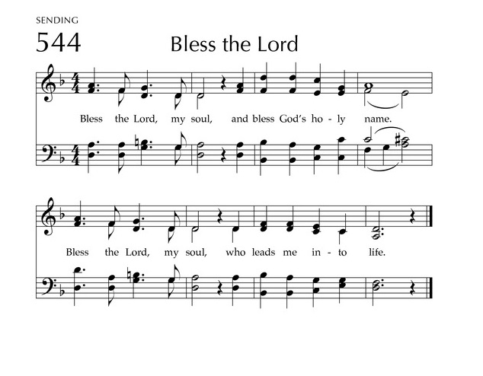
Prayers of the People/Lord’s Prayer

Our Father who art in heaven, hallowed be thy name.
Thy Kingdom come, thy will be done, on earth as it is in heaven.
Give us this day our daily bread;
and forgive us our debts, as we forgive our debtors;
and lead us not into temptation, but deliver us from evil.
For thine is the kingdom, and the power and the glory, forever. Amen

Final Song (306) “Fairest Lord Jesus”

Blessing and Sending

Postlude

We are glad you chose to spend your Sunday morning with us, and we encourage you to return!

Children of all ages are welcome in worship. Children’s worship materials are available from the book cart. A Cry Room is located at the back of the sanctuary

Coming soon…. a fascinating afternoon of fellowship and education next Sunday, April 26, at 2 p.m. at Sue and Jeff May’s home. They have invited us to their home for a program about their extended trip to Kenya and Tanzania last summer. Sue lived in Africa from age 3 mos. to five years where her father worked for USAID and developed a corn hybrid that is still being used very successfully today in the area. Again that's next Sunday, April 26, at 2 p.m. at Sue and Jeff's home at 2501 Sheridan Drive here in Norfolk. If you plan to attend, please RSVP to 605-660-4137 or email slmay312@gmail.com so they know how many to expect.

Minute for Mission on 4/26/26 – Orphan Grain Train

Construction Update . . . Until further notice, access to the Education Wing will be restricted. If you need anything in the Education Wing, please contact Erin Beckenhauer, (402) 669-0195 or Renée McClymont, (402)750-0180).
The Fellowship Hall will be closed Mon-Fri, 8am-5pm due to construction.

Food Pantry. May is the month for FPC to serve the Food Pantry. A sign-up sheet is in the narthex. Three volunteers are needed each day. Please give prayerful thought to fulfilling our mission. Thank You!

Deacons Project for April is The Orphan Grain Train. In loving response to Christ, the Servant, the Orphan Grain Train encourages and enables God’s people to share personal and material resources to needy people both far and near. Grain Train volunteers gather donations of clothing, medical supplies, food and other aid to meet real needs. 97% of all monies go directly to missions, with only 3% used for overhead expenses.

Birthdays

Andrew Praeuner 4/19
Greta Johnson 4/23
Jabin Sateren 4/24
Mary Birch 4/30

Anniversaries

None this week

Prayers for God’s Children

For healing and pain relief for those living with physical and emotional pain and for their families and friends
For our members who are home-bound or in nursing facilities
For our mission partners
For the men and women serving in our armed forces

This Week at First Pres

Today: 10:00 AM – Worship
7:00 PM – 10:00 PM N/A (fellowship hall)
Monday: 8:30 AM – 10:30 AM N/A (fellowship hall)
Tuesday: 8:00 PM – 9:30 PM N/A (fellowship hall)
Wednesday: 2:00 PM – Bulletin Information Deadline
6:45 PM – Choir Rehearsal
Saturday: 8:30 AM – 10:00 AM The Link

Next Sunday

10:00 AM – Worship
10:00 AM – Good Morning, Good News

Elders Deacons
Class of 2026 Class of 2026
Dennis Sateren, Missions Doug Kuper
Barb Beckmann, Worship/Cong. Kathy Sateren
Erin Beckenhauer, Worship/Cong.
Class of 2027 Class of 2027
Marci Pierce, Personnel Sherry Johnson, Treasurer
Jake Cox Sue May
Dave Unkel, Co-Moderator
Class of 2028 Class of 2028
Jeff May, Finance Dave Gerharter
Don Burns, Properties Sonja Jones, Co-Moderator
Kerry Richter, Christian Ed Kim Rusk, Secretary

Renée McClymont, Clerk of Session, Class of 2026

Elders of the Month – Kerry Richter & Jake Cox

2026 YTD Financials – through February 28th, 2026
Receipts $46,549.45 – Disbursements $37,348.74 = Net $9,200.71
Last Sunday Attendance 41

Worship Leaders & Staff
PASTOR Rev. Brian Johnson
MUSIC DIRECTOR Greta Johnson ORGANIST Steve Reinke
SOUND TEAM Joe Mtika, Barb Beckmann, Jeff May
PRAISE TEAM Katie Tillman, Addy Rusk, Brynn Rusk
LAY READER Marci Pierce

Office hours: 9 am to 1 pm Mon.
9 am to 4 pm Tues. – Thur.
9 am to 1 pm Fri.
or other times by appointment
E-Mail: Karen@firstpresnorfolk.com
Website: firstpresnorfolk.com

