First Presbyterian Church

104 So. 10th St., Norfolk, NE 68701
Phone: 402-371-1635

March 1, 2026



Mission Statement

Proclaiming the Love of Christ
in the Heart of Norfolk
Since 1896
Order of Worship
Sunday Worship, March 1, 2026
Second Sunday in Lent
First PC, Norfolk, NE

Leader: The grace of the Lord Jesus Christ be with you all.
People: And also with you.

Welcome and Announcements
Minute for Mission – Rhonda Wrenholt with Mercy Meals

Starvation among children remains one of the gravest humanitarian crises in the world today. According to UNICEF, around 45 million children under the age of five suffer from wasting, the most visible and severe form of malnutrition. Starvation not only stunts growth but also impairs cognitive development and increases the risk of disease and death.

Poverty is the most direct cause but is followed closely by conflict and political instability in today’s world. Recently, climate change has worsened food insecurity by contributing to droughts, floods, and other extreme conditions that damage crops and livelihoods.

Solving child starvation requires global action. Governments must invest in sustainable agriculture, food distribution systems and social safety nets. Humanitarian organizations need better funding and support to deliver aid efficiently. People around the world can support organizations fighting hunger. No child should suffer or die due to lack of food in a world that has enough for everyone.

Mercy Meals packages serve up to 6 children with all the essential nutrients needed to reverse malnutrition.

Passing of the Peace

Leader: The peace of the Lord Jesus Christ be with you all!
People: And also with you.

Let us share signs of Christ’s peace with one another
Call to Worship
Leader: I lift up my eyes to the hills – from where does my
help come?
People: My help comes from the Lord, the Maker of
heaven and earth.
Leader: He will not let your foot slip – he who watches over
you will not slumber;
People: indeed, he who watches over Israel will neither
slumber nor sleep.
Leader: The Lord watches over you – the Lord is your
shade at your right hand;
People: the sun will not harm you by day, nor the moon
by night.
Leader: The Lord will keep you from all harm – he will
watch over your life;
People: the Lord will watch over your coming and going
both now and forevermore.
-- Psalm 121
Opening Song (Praise Band)
“How Deep the Father’s Love for Us”

Call to Confession
Remember that our Lord Jesus can sympathize with us in our weaknesses, since in every respect he was tempted as we are, yet without sin. Let us then with boldness approach the throne of grace, that we may receive mercy and find grace to help in time of need. Let us confess our sins against God and our neighbor.

Prayer of Confession
God of mercy, you sent Jesus Christ to seek and save the lost. We confess that we have strayed from you and turned aside from your way. We are misled by pride, for we see ourselves pure when we are stained, and great when we are small. We have failed in love, neglected justice, and ignored your truth. Have mercy, O God, and forgive our sin. Return us to paths of righteousness through Jesus Christ, our Savior.

(We observe a time of silence for personal confession.)

Lenten Response

Leader: O Christ, you are our eternal hope.
People: Save us, Lord.
Leader: O Christ, on the cross you were wounded for
our transgressions.
People: Save us, Lord.
Leader: O Christ, our life and resurrection, our peace and
reconciliation:
People: Save us, Lord.

Response (579) “Glory to the Father (Gloria Patri)”

Choir Anthem “Speak, O Lord”

The Word

Children’s Message
Scripture John 3:1-17
Message “Saving the World” Pastor Brian
Song of Response (80)
“Jesus Walked This Lonesome Valley”
Offering our Gifts

Offertory

Response (592) “Praise God, from Whom All Blessings Flow”
(Doxology)

Song of Preparation for Prayer (insert)
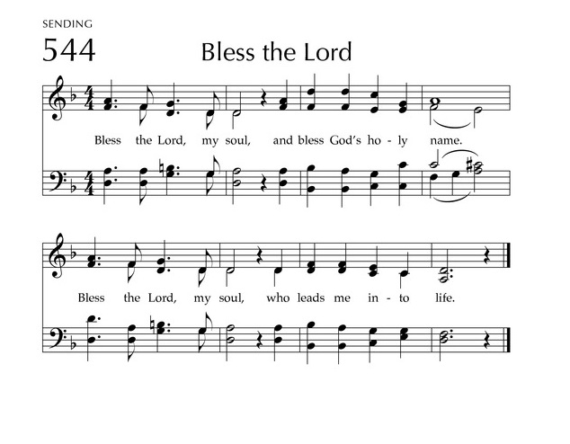
Prayers of the People/Lord’s Prayer

Our Father who art in heaven, hallowed be thy name.
Thy Kingdom come, thy will be done, on earth as it is in heaven.
Give us this day our daily bread;
and forgive us our debts, as we forgive our debtors;
and lead us not into temptation, but deliver us from evil.
For thine is the kingdom, and the power and the glory, forever. Amen

Communion
Invitation to the Table
Words of Institution
Sharing the Sacrament
Prayer

Final Song (514) “Let Us Talents and Tongues Employ”

Blessing and Sending

Postlude

We are glad you chose to spend your Sunday morning with us, and we encourage you to return!

Children of all ages are welcome in worship. Children’s worship materials are available from the book cart. A Cry Room is located at the back of the sanctuary

The Meals on Wheels deliveries for First Presbyterian Church will be Mar 2nd – Mar 13th. There are three routes to fill and two people will be needed for each route. Delivery days will be Monday - Friday. Sign-up sheet in narthex.

The Executive Commission of Session approved use of the Youth Room by the Zone After School Program, Fridays, 4-5:30pm, from March 6 through April 3, 2026.

The Per Capita for First Presbyterian Church is $38.96 per person for 2026.

Easter Egg Hunt is scheduled for Saturday, March 28 at 11:00am at First Congregational Church, 1102 W. Norfolk Ave. (rain/snow date is Sat. 4/4) Ages thru 5th grade. Flyer on bulletin board in narthex.

The Deacons Project for March is Mercy Meals. Mercy Meals of Nebraska works in conjunction with the Orphan Grain Train to pack and distribute nourishing food to children throughout the world. By volunteering one hour of your time you can provide enough food to feed a child for one year. Working together we can make a difference.

Birthdays

Gerry Hoppe 3/01
Ethan Rusk 3/01
Janelle Gerharter 3/05
Shelley Dahl 3/11
Preston Rusk 3/11
Sue May 3/12

Anniversaries

John & Chris Judt 3/06

Prayers for God’s Children

For healing and pain relief for those living with physical and emotional pain and for their families and friends
For our members who are home-bound or in nursing facilities
For our mission partners
For the men and women serving in our armed force

This Week at First Pres
Today: 10:00 AM – Worship
7:00 PM – 10:00 PM N/A (fellowship hall)
Monday: 8:30 AM – 10:30 AM N/A (fellowship hall)
Tuesday: 8:00 PM – 9:30 PM N/A (fellowship hall)
Wednesday: 2:00 PM – Bulletin Information Deadline
6:45 PM – Choir Rehearsal
Saturday: 8:30 AM – 10:00 AM The Link

Next Sunday
10:00 AM – Worship
10:00 AM – Good Morning, Good News

Elders Deacons
Class of 2026 Class of 2026
Dennis Sateren, Missions Doug Kuper
Barb Beckmann, Worship/Cong. Kathy Sateren
Erin Beckenhauer, Worship/Cong.
Class of 2027 Class of 2027
Marci Pierce, Personnel Sherry Johnson, Treasurer
Jake Cox, Properties Sue May
Dave Unkel, Co-Moderator
Class of 2028 Class of 2028
Jeff May, Finance Dave Gerharter
Don Burns Sonja Jones, Co-Moderator
Kerry Richter, Christian Ed Kim Rusk, Secretary

Renée McClymont, Clerk of Session, Class of 2026

Elders of the Month – Barb Beckmann & Dennis Sateren

2025 YTD Financials – through December 31st, 2025
Receipts $217,240.28 – Disbursements $256,721.26 = Net <$39,480.98>
Last Sunday Attendance 47

Worship Leaders & Staff

PASTOR Rev. Brian Johnson
MUSIC DIRECTOR Greta Johnson ORGANIST Steve Reinke
SOUND TEAM Joe Mtika, Barb Beckmann, Jeff May
PRAISE TEAM Katie Tillman, Addy Rusk, Brynn Rusk
LAY READER Ann Letheby

Office hours: 9 am to 1 pm Mon.
9 am to 4 pm Tues. – Thur.
9 am to 1 pm Fri.
or other times by appointment

E-Mail: Karen@firstpresnorfolk.com
Website: firstpresnorfolk.com

