First Presbyterian Church

104 So. 10th St., Norfolk, NE 68701
Phone: 402-371-1635

June 14, 2026



Mission Statement

Proclaiming the Love of Christ
in the Heart of Norfolk
Since 1896
Order of Worship
Sunday Worship, June 14, 2026
Third Sunday After Pentecost
First PC, Norfolk, NE

Prelude

Leader: The grace of the Lord Jesus Christ be with you!
People: And also with you.

Welcome and Announcements

Passing of the Peace

Leader: The peace of the Lord Jesus Christ be with you all!
People: And also with you.
Leader: Let us share signs of Christ’s peace with one
another.

Call to Worship

Leader: Shout for joy to the Lord, all the earth!
People: Worship the Lord with gladness, come before
him with joyful songs.
Leader: Know that the Lord is God;
People: It is he who made us and we are his.
Leader: We are his people, the sheep of his pasture.
People: Enter his gates with thanksgiving, and his
courts with praise.
Leader: Give thanks to him and praise his name.
People: For the Lord is good and his love endures
forever.
All: His faithfulness continues through all
generations.
-- Psalm 100

Opening Hymn (476)
“O Worship the King, All Glorious Above”

Call to Confession

The proof of God’s amazing love is this: While we were sinners Christ died for us. Because we have faith in him, we dare to approach God with confidence. In faith and penitence, let us confess our sin before God and one another.

Prayer of Confession

Holy and merciful God, in your presence we confess our sinfulness, our shortcomings, and our offenses against you. You alone know how often we have sinned in wandering from your ways, in wasting your gifts, in forgetting your love. Have mercy on us, O Lord, for we are ashamed and sorry for all we have done to displease you. Forgive our sins, and help us to live in your light, and walk in your ways, for the sake of Jesus Christ our Savior.

(We observe a time of silence for personal confession.)

Assurance of Pardon

Leader: Friends, hear the Good News! God has shown us
how much he loves us.
People: It is while we were yet sinners that Christ died
for us.
Leader: Friends, believe the good news!
People: In Jesus Christ, we are forgiven.

Response (579) “Glory to the Father (Gloria Patri)”

Special Music “The Wonderful Cross”
led by Praise Band

The Word

Scripture Matthew 9:35-10:16
Message “Snakes and Doves” Pastor Brian

Special Music Greta Johnson

Offering our Gifts

Offertory

Response (592) “Praise God, from Whom All Blessings Flow”
(Doxology)

Song of Preparation

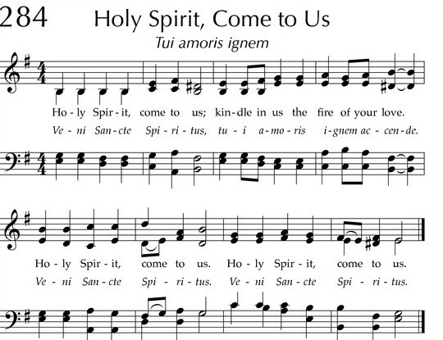

Prayers of the People/Lord’s Prayer

Our Father who art in heaven, hallowed be thy name.
Thy Kingdom come, thy will be done, on earth as it is in heaven.
Give us this day our daily bread;
and forgive us our debts, as we forgive our debtors;
and lead us not into temptation, but deliver us from evil.
For thine is the kingdom, and the power and the glory, forever. Amen

Final Song (343)
“Called as Partners in Christ’s Service”

Blessing and Sending

Postlude

We are glad you chose to spend your Sunday morning with us, and we encourage you to return!

Children of all ages are welcome in worship. Children’s worship materials are available from the book cart. A Cry Room is located at the back of the sanctuary

Construction Update . . . Until further notice, access to the Education Wing will be restricted. If you need anything in the Education Wing, please contact Erin Beckenhauer, (402) 669-0195 or Renée McClymont, (402)750-0180).
The Fellowship Hall will be closed Mon-Fri, 8am-5pm due to construction.

The Deacon’s Mission Giving Project for June is Bright Horizons. Bright Horizons began in 1976 with one woman opening her home for abused victims in the Norfolk area. As time went by she realized that there was a lot more that could be done to help victims of domestic and sexual violence. She worked to establish a non-profit corporation and, on January 26, 1978, “Norfolk Task Force on Domestic Violence” and its Articles of Incorporation were filed with the Secretary of State of Nebraska and today cover Antelope, Boyd, Holt, Knox, Madison, Pierce, and Stanton counties.

Birthdays

Heather Hardisty 6/14
Steve Reinke 6/28

Anniversaries

Tino & Kathy Naranjo 6/21
Warren & Karen Reimer 6/22

Prayers for God’s Children

For healing and pain relief for those living with physical and emotional pain and for their families and friends
For our members who are home-bound or in nursing facilities
For our mission partners
For the men and women serving in our armed forces

This Week at First Pres

Today: 10:00 AM – Worship
Monday: 8:30 AM – 10:30 AM N/A (fellowship hall)
Tuesday: 8:00 PM – 9:30 PM N/A (fellowship hall)
Wednesday: 2:00 PM – Bulletin Information Deadline
Friday 4:00 PM – 5:30 PM The Zone/Youth Room
Saturday: 8:30 AM – 10:00 AM The Link

Next Sunday
10:00 AM – Worship

Elders Deacons
Class of 2026 Class of 2026
Dennis Sateren, Missions Doug Kuper
Barb Beckmann, Worship/Cong. Kathy Sateren
Erin Beckenhauer, Worship/Cong.
Class of 2027 Class of 2027
Marci Pierce, Personnel Sherry Johnson, Treasurer
Jake Cox Sue May
Dave Unkel, Co-Moderator
Class of 2028 Class of 2028
Jeff May, Finance Dave Gerharter
Don Burns, Properties Sonja Jones, Co-Moderator
Kerry Richter, Christian Ed Kim Rusk, Secretary

Renée McClymont, Clerk of Session, Class of 2026

Elders of the Month – Marci Pierce & Dennis Sateren

2026 YTD Financials – through April 30th, 2026
Receipts $74,706.64 – Disbursements $75,436.16 = Net <$729.52>
Last Sunday Attendance 40

PASTOR Rev. Brian Johnson
MUSIC DIRECTOR Greta Johnson ORGANIST Steve Reinke
SOUND TEAM Joe Mtika, Barb Beckmann, Jeff May
PRAISE TEAM Katie Tillman, Addy Rusk, Brynn Rusk
LAY READER Dennis Sateren

Office hours: 9 am to 1 pm Mon.
9 am to 4 pm Tues. – Thur.
9 am to 1 pm Fri.
or other times by appointment
Worship Leaders & Staff

E-Mail: Karen@firstpresnorfolk.com
Website: firstpresnorfolk.com



