First Presbyterian Church

104 So. 10th St., Norfolk, NE 68701
Phone: 402-371-1635

December 7, 2025



Mission Statement

Proclaiming the Love of Christ
in the Heart of Norfolk
Since 1896
Order of Worship
Sunday Worship, December 7, 2025
Second Sunday of Advent
First PC, Norfolk, NE

Leader: The grace of the Lord Jesus Christ be with you all.
People: And also with you.

Welcome and Announcements

Passing of the Peace
Leader: The peace of the Lord Jesus Christ be with you all!
People: And also with you.

Let us share signs of Christ’s peace with one another

Call to Worship

Leader: Endow the king with your justice, O God; the royal
son with your righteousness.
People: He will judge your people in righteousness,
your afflicted ones with justice.
Leader: The mountains will bring prosperity to the people;
the hills the fruit of righteousness.
People: He will defend the afflicted among the people
and save the children of the needy; he will
crush the oppressor.
Leader: He will endure as long as the sun, as long as the
moon, through all generations.
People: He will be like rain falling on a mown field, like
showers watering the earth.
Leader: Praise be to the Lord God, the God of Israel, who
alone does marvelous deeds.
People: Praise be to his glorious name forever; may the
whole earth be filled with his glory.
All: Amen and amen! -- Psalm 72: 1-7, 18-19
Lighting of the Advent Candle &
Advent Reading – “Peace”
Prayer Barb Beckmann & Shelley Dahl

Opening Song (video) “Emmanuel”

Call to Confession

The proof of God’s amazing love is this: While we were sinners Christ died for us. Because we have faith in him, we dare to approach God with confidence. In faith and penitence, let us confess our sin before God and one another.

Prayer of Confession

God of the future, you are coming in power to bring all nations under your rule. We confess that we have not expected your kingdom, for we live casual lives, ignoring your promised judgment. We accept lies as truth, exploit neighbors, abuse the earth, and refuse your justice and peace. In your mercy, forgive us. Grant us wisdom to welcome your way, and to seek things that endure when Christ comes to judge the world.

(We observe a time of silence for personal confession.)

Assurance of Pardon

Leader: Friends, hear the Good News! God has given you
grace and peace in Christ Jesus,
People: and enriched us with many good gifts.
Leader: Friends, believe the Good News!
People: In Jesus Christ, we are forgiven.

Response (579) “Glory to the Father (Gloria Patri)”

Choir Anthem “Advent Processional”
(back page of bulletin)

The Word

Children’s Message
Scripture Romans 15:4-13
Message “Hope for Peace” Pastor Brian

Song of Response (420)
“God of Grace and God of Glory”

Offering our Gifts

Offertory
Response (592) “Praise God, from Whom All Blessings Flow”
(Doxology)

Song of Preparation (insert)
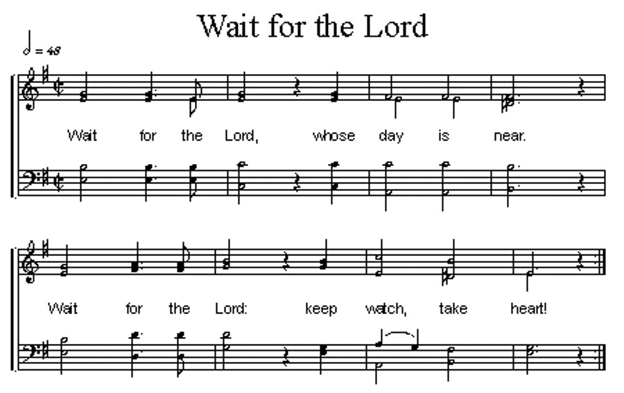
Prayers of the People/Lord’s Prayer

Our Father who art in heaven, hallowed be thy name.
Thy Kingdom come, thy will be done, on earth as it is in heaven.
Give us this day our daily bread;
and forgive us our debts, as we forgive our debtors;
and lead us not into temptation, but deliver us from evil.
For thine is the kingdom, and the power and the glory, forever. Amen

Communion
Invitation to the Table
Words of Institution
Sharing the Sacrament
Prayer

Final Song (22) “Angels from the Realms of Glory”

Blessing and Sending

Postlude

We are glad you chose to spend your Sunday morning with us, and we encourage you to return!

Children of all ages are welcome in worship. Children’s worship materials are available from the book cart. A Cry Room is located at the back of the sanctuary.

A Christmas program, Christmas: The Proclamations, to be presented during worship on December 21. Thirteen children and youth, and one adult will participate in the program.

“Warmth, Peace and Pajamas” The Salvation Army is again collecting new pajamas, mittens, socks, etc. for the pajama project. The timeframe to donate is 11/17/25-12/11/25.
We need readers for Advent – Dec. 14th & 21st
There is a sign-up sheet in the narthex.

The Deacon’s Mission Giving Project for December is Good Neighbors. Good Neighbors helps provide clothes or essential supplies in emergency situations or pay rent or a utility bill for those who qualify. The program also provides food for families and Christmas gifts for needy children.

Birthdays

Curtis Wolff 12/09
Jim Zittritsch 12/14
Doug Kuper 12/18
Joe Reynolds 12/18

Anniversaries

Buster & Linda Beckenhauer 12/20

Prayers for God’s Children

For healing and pain relief for those living with physical and emotional pain and for their families and friends
For our members who are home-bound or in nursing facilities
For our mission partners
For the men and women serving in our armed force

This Week at First Pres
Today: 10:00 AM – Worship
11:15 AM – Handbell Rehearsal
7:00 PM – 10:00 PM N/A (fellowship hall)
Monday: 8:30 AM – 10:30 AM N/A (fellowship hall)
7:00 PM – Deacons
Tuesday: 8:00 PM – 9:30 PM N/A (fellowship hall)
Wednesday: 2:00 PM – Bulletin Information Deadline
6:45 PM – Choir Rehearsal
Saturday: 8:30 AM – 10:00 AM The Link
Next Sunday
10:00 AM – Worship
10:00 AM – Good Morning, Good News

Elders Deacons
Class of 2025 Class of 2025
Teri Wendel, Christian Ed. Shelley Dahl, Secretary
Dave Gerharter, Finance Sonja Jones, Co-Moderator
Pat McCollough, Properties Mary Osborne, Co-Moderator
Class of 2026 Class of 2026
Dennis Sateren, Missions Doug Kuper
Barb Beckmann Worship/Cong. Kathy Sateren
Erin Beckenhauer, Worship/Cong.
Class of 2027 Class of 2027
Marci Pierce, Personnel Sherry Johnson, Treasurer
Sue May
Dave Unkel

Renée McClymont, Clerk of Session, Class of 2026

Elders of the Month – Erin Beckenhauer & Dave Gerharter

2025 YTD Financials – through October 31st, 2025
Receipts $163,177.10 – Disbursements $212,927.69 = Net <$49,750.59>
Last Sunday Attendance 36

Worship Leaders & Staff

PASTOR Rev. Brian Johnson
MUSIC DIRECTOR Greta Johnson ORGANIST Steve Reinke
SOUND TEAM Joe Mtika, Barb Beckmann, Jeff May
PRAISE TEAM Kim Rusk, Brynn Rusk, Joe Mtika
LAY READER Barb Beckmann

Credits: “Emmanuel” by Amy Grant
is used under CCLI license #1820283
Office hours: 9 am to 1 pm Mon.
9 am to 4 pm Tues. – Thur.
9 am to 1 pm Fri.
or other times by appointment

E-Mail: Karen@firstpresnorfolk.com
Website: firstpresnorfolk.com

Advent Processional

We will keep our eyes fixed on Jesus,
Keep our eyes fixed on Jesus.
Keep our eyes fixed on Jesus
Till He comes again.

We will wait on Him, wait with hope,
Wait on Him, wait with hope.
Wait on Him, wait with hope
Till He comes again.

Come, O Rose of Sharon,
Come, O Prince of Peace,
Come, O Rose of Sharon,
Come, Emmanuel.

We will reach our hands out in service,
Reach our hands out in service.
Reach our hands out in service
Till He comes again.

We will dry the tears of one another,
Dry the tears of one another,
Dry the tears of one another
Till He comes again.

Come, O Rose of Sharon,
Come, O Prince of Peace,
Come, O Rose of Sharon,
Come, Emmanuel.

O come, Lord Jesus, come.

