First Presbyterian Church

104 So. 10th St., Norfolk, NE 68701
Phone: 402-371-1635

April 12, 2026



Mission Statement

Proclaiming the Love of Christ
in the Heart of Norfolk
Since 1896

Order of Worship
Sunday Worship, April 12, 2026
Second Sunday of Easter
First PC, Norfolk, NE

Prelude

Leader: The grace of the Lord Jesus Christ be with
you all .
People: And also with you.

Welcome and Announcements

Passing of the Peace

Leader: The peace of the Lord Jesus Christ be with you all!
People: And also with you.

Call to Worship

Leader: Lord you have assigned me my portion and my cup;
People: you have made my lot secure.
Leader: Therefore, my heart is glad and my tongue rejoices;
People: my body will also rest secure.
Leader: You have made known to me the path of life;
People: you will fill me with joy in your presence, with
eternal pleasures at your right hand.

-- Psalm 16: 5, 9, 11

Opening Hymn (119): “The Strife Is O’er”

Call to Confession

The proof of God’s amazing love is this: While we were sinners Christ died for us. Because we have faith in him, we dare to approach God with confidence. In faith and penitence, let us confess our sin before God and one another.

Prayer of Confession

Almighty God, in raising Jesus from the grave, you shattered the power of sin and death. We confess that we remain captive to doubt and fear, bound by the ways that lead to death. We overlook the poor and the hungry, and pass by those who mourn; we are deaf to the cries of the oppressed, and indifferent to calls for peace; we despise the weak, and abuse the earth you made. Forgive us, God of mercy. Help us to trust your power to change our lives and make us new, that we may know the joy of life abundant given in Jesus Christ, the risen Lord

(We observe a time of silence for personal confession.)

Assurance of Pardon

Leader: Friends, hear the Good News! God has given us a
new birth.
People: With great mercy, God has given us a living
hope, through the resurrection of Jesus Christ
from the dead.
Leader: Friends, believe the Good News!
People: In Jesus Christ, we are forgiven.

Response (579) “Glory to the Father (Gloria Patri)”

Choir Anthem “Our Savior Is Alive”
(back page of bulletin)

The Word

Scripture 1John 5:1-13
Message “Confidence” Pastor Brian

Song of Response “Spirit of the Living God”
led by Praise Band

Offering our Gifts

Offertory

Response (592) “Praise God, from Whom All Blessings Flow”
(Doxology)

Song of Preparation for Prayer (insert)
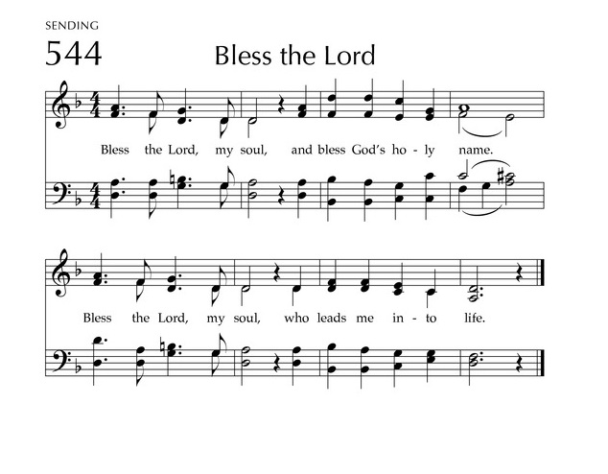
Prayers of the People/Lord’s Prayer

Our Father who art in heaven, hallowed be thy name.
Thy Kingdom come, thy will be done, on earth as it is in heaven.
Give us this day our daily bread;
and forgive us our debts, as we forgive our debtors;
and lead us not into temptation, but deliver us from evil.
For thine is the kingdom, and the power and the glory, forever. Amen

Final Song (446) “Glorious Things of Thee Are Spoken”

Blessing and Sending

Postlude

We are glad you chose to spend your Sunday morning with us, and we encourage you to return!

Children of all ages are welcome in worship. Children’s worship materials are available from the book cart. A Cry Room is located at the back of the sanctuary

Construction Update . . . Until further notice, access to the Education Wing will be restricted. If you need anything in the Education Wing, please contact Erin Beckenhauer, (402) 669-0195 or Renée McClymont, (402)750-0180).
The Fellowship Hall will be closed Mon-Fri, 8am-5pm due to construction.

Food Pantry. May is the month for FPC to serve the Food Pantry. A sign-up sheet is in the narthex. Three volunteers are needed each day. Please give prayerful thought to fulfilling our mission. Thank You!

Calvin Crest Summer Camp Schedule – Pricing, camp descriptions & dates are available at www.calvincrest.camp.
Calvin Crest is located at 2870 County Road 13, Fremont, NE 68025.

Deacons Project for April is The Orphan Grain Train. In loving response to Christ, the Servant, the Orphan Grain Train encourages and enables God’s people to share personal and material resources to needy people both far and near. Grain Train volunteers gather donations of clothing, medical supplies, food and other aid to meet real needs. 97% of all monies go directly to missions, with only 3% used for overhead expenses.

Birthdays

Ruth Anderson 4/14
Mark Losse 4/18
Andrew Praeuner 4/19
Greta Johnson 4/23
Jabin Sateren 4/24

Anniversaries

None this week

Prayers for God’s Children

For healing and pain relief for those living with physical and emotional pain and for their families and friends
For our members who are home-bound or in nursing facilities
For our mission partners
For the men and women serving in our armed forces

This Week at First Pres

Today: 10:00 AM – Worship
7:00 PM – 10:00 PM N/A (fellowship hall)
Monday: 8:30 AM – 10:30 AM N/A (fellowship hall)
7:00 PM – Deacons
Tuesday: 8:00 PM – 9:30 PM N/A (fellowship hall)
Wednesday: 2:00 PM – Bulletin Information Deadline
6:45 PM – Choir Rehearsal
Saturday: 8:30 AM – 10:00 AM The Link

Next Sunday
10:00 AM – Worship
10:00 AM – Good Morning, Good News

Elders Deacons
Class of 2026 Class of 2026
Dennis Sateren, Missions Doug Kuper
Barb Beckmann, Worship/Cong. Kathy Sateren
Erin Beckenhauer, Worship/Cong.
Class of 2027 Class of 2027
Marci Pierce, Personnel Sherry Johnson, Treasurer
Jake Cox Sue May
Dave Unkel, Co-Moderator
Class of 2028 Class of 2028
Jeff May, Finance Dave Gerharter
Don Burns, Properties Sonja Jones, Co-Moderator
Kerry Richter, Christian Ed Kim Rusk, Secretary

Renée McClymont, Clerk of Session, Class of 2026

Elders of the Month – Kerry Richter & Jake Cox

2026 YTD Financials – through February 28th, 2026
Receipts $46,549.45 – Disbursements $37,348.74 = Net $9,200.71
Last Sunday Attendance 78

Worship Leaders & Staff
PASTOR Rev. Brian Johnson
MUSIC DIRECTOR Greta Johnson ORGANIST Steve Reinke
SOUND TEAM Joe Mtika, Barb Beckmann, Jeff May
PRAISE TEAM Katie Tillman, Addy Rusk, Brynn Rusk
LAY READER Dennis Sateren
Office hours: 9 am to 1 pm Mon.
9 am to 4 pm Tues. – Thur.
9 am to 1 pm Fri.
or other times by appointment
E-Mail: Karen@firstpresnorfolk.com
Website: firstpresnorfolk.com

Our Savior Is Alive!
There is good news this mornin,’
Good news this mornin,’
There is good news this mornin,’
Hallelu!
There is good news this mornin,’
Gonna shout it on high.
Hallelujah! Our Savior is alive!

There is great jubilation!
Glory hallelu.
Come and see where the stone is rolled away.
Jesus is risen! Jesus is risen!
Come rejoice this bright Easter day.

He has brought us salvation.
Glory hallelu.
Come and sing out a joyful song of praise.
Come and sing hallelujah, sing hallelujah.
Christ our Lord is risen today!

There is good news this mornin,’
Good news this mornin,’
There is good news this mornin,’
Hallelu!
There is good news this mornin,’
Gonna shout it on high.
Hallelujah! Our Savior is alive!

He’s alive, yes, our Savior is alive!

