First Presbyterian Church

104 So. 10th St., Norfolk, NE 68701
Phone: 402-371-1635

February 8, 2026



Mission Statement

Proclaiming the Love of Christ
in the Heart of Norfolk
Since 1896
Order of Worship
Sunday Worship, February 8, 2026
Fifth Sunday after Epiphany
First PC, Norfolk, NE

Leader: The grace of the Lord Jesus Christ be with you all.
People: And also with you.

Welcome and Announcements

Passing of the Peace

Leader: The peace of the Lord Jesus Christ be with you all!
People: And also with you.

Let us share signs of Christ’s peace with one another

Call to Worship

Leader: Blessed is the man who fears the Lord, who finds
great delight in his commands.
People: His children will be mighty in the land; the
generation of the upright will be blessed.
Leader: Wealth and riches are in his house, and his
righteousness endures forever.
People: Even in darkness, light dawns for the upright,
for the gracious and compassionate and righteous man.
Leader: Good will come to him who is generous and lends
freely,
People: who conducts his affairs with justice.
Leader: He has scattered abroad his gifts to the poor,
People: his righteousness endures forever; his horn
will be lifted high in honor.
--Psalm 112:1-5, 9
Opening Song (led by Praise Band)
“Open the Eyes of My Heart, Lord”

Call to Confession

Remember that our Lord Jesus can sympathize with us in our weaknesses, since in every respect he was tempted as we are, yet without sin. Let us then with boldness approach the throne of grace, that we may receive mercy and find grace to help in time of need. Let us confess our sins against God and our neighbor.

Prayer of Confession

God of glory, you sent Jesus among us as the light of the world, to reveal your love for all people. We confess that our sin and pride hide the brightness of your light. We turn away from the poor; we ignore cries for justice; we do not strive for peace. In your mercy, cleanse us of our sin, and baptize us once again with your Spirit, that, forgiven and renewed, we may show forth your glory shining in the face of Jesus Christ.

(We observe a time of silence for personal confession.)

Assurance of Pardon

Leader: Friends, hear the Good News! Christ nailed to the
cross attests the cost of God’s love and forgiveness.
People: Our faith is not built on human wisdom, but on
the power of God.
Leader: Friends, believe the Good News!
People: In Jesus Christ, we are forgiven.

Response (579) “Glory to the Father (Gloria Patri)”
Choir Anthem “I’m Gonna Tell the Gospel Story”
(lyrics on back of bulletin)

The Word

Scripture Matthew 5:13-20
Message “Properly Seasoned” Pastor Brian

Song of Response (374)
“Lord, Make Us Servants of Your Peace”

Offering our Gifts

Offertory

Response (592) “Praise God, from Whom All Blessings Flow”
(Doxology)

Song of Preparation (insert)
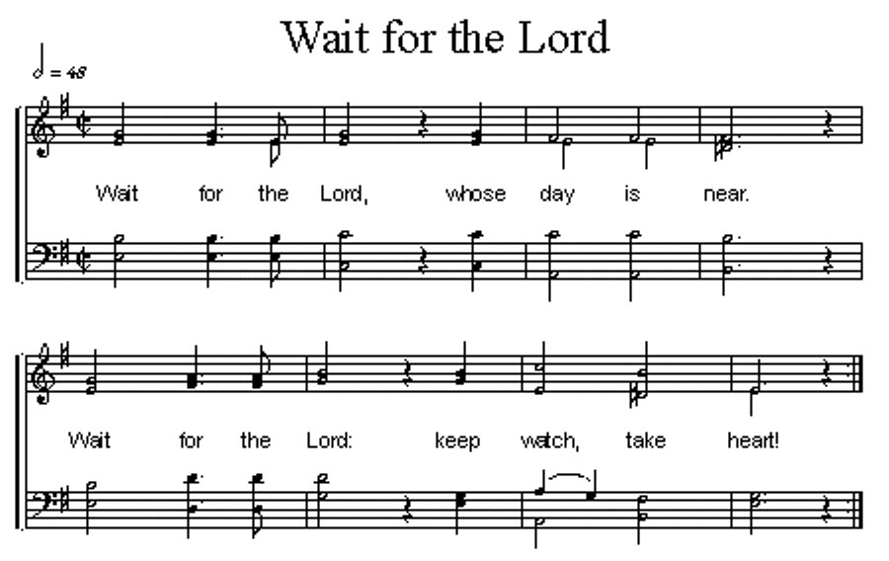
Prayers of the People/Lord’s Prayer

Our Father who art in heaven, hallowed be thy name.
Thy Kingdom come, thy will be done, on earth as it is in heaven.
Give us this day our daily bread;
and forgive us our debts, as we forgive our debtors;
and lead us not into temptation, but deliver us from evil.
For thine is the kingdom, and the power and the glory, forever. Amen

Final Hymn (316) “Breathe on Me, Breath of God”

Blessing and Sending

Postlude

We are glad you chose to spend your Sunday morning with us, and we encourage you to return!

Children of all ages are welcome in worship. Children’s worship materials are available from the book cart. A Cry Room is located at the back of the sanctuary

The Per Capita for First Presbyterian Church is $38.96 per person for 2026.

Annual Congregational Meeting today, Feb. 8, 2026. Please plan to join us after worship service for a ‘picnic’ lunch in the Fellowship Hall in the church basement followed by the annual meeting.

The Deacons Project for February is Norfolk Rescue Mission. Since 1996, the Norfolk Rescue Mission has provided a safe haven for people who are hurting, homeless or in need of a friend. The Mission provides not only assistance with food and shelter, but it also helps those staying at its facilities to become responsible, contributing members of the church and society.
Our Lenten Study for this year is “Celebration of Discipline” by Richard J. Foster. Study will begin on Tuesday, Feb. 24th at 6:30pm. A sign-up sheet is in the narthex.

Birthdays

Eugene Sateren 2/11
Whitney Beckenhauer 2/17
Teri Wendel 2/20
Lasten Mchilima 2/21

Anniversaries
None this week

Prayers for God’s Children

For healing and pain relief for those living with physical and emotional pain and for their families and friends
For our members who are home-bound or in nursing facilities
For our mission partners
For the men and women serving in our armed force

This Week at First Pres
Today: 10:00 AM – Worship
7:00 PM – 10:00 PM N/A (fellowship hall)
11:00 AM – Lunch/Annual Meeting
Monday: 8:30 AM – 10:30 AM N/A (fellowship hall)
7:00 PM – Deacons
Tuesday: 8:00 PM – 9:30 PM N/A (fellowship hall)
Wednesday: 2:00 PM – Bulletin Information Deadline
6:45 PM – Choir Rehearsal
Thursday 1-4:00 PM – Zone Youth Group/Valentine Party
Saturday: 8:30 AM – 10:00 AM The Link

Next Sunday
10:00 AM – Worship
10:00 AM – Good Morning, Good News

Elders Deacons
Class of 2026 Class of 2026
Dennis Sateren, Missions Doug Kuper
Barb Beckmann, Worship/Cong. Kathy Sateren
Erin Beckenhauer, Worshi
p/Cong.
Class of 2027 Class of 2027
Marci Pierce, Personnel Sherry Johnson, Treasurer
Jake Cox, Properties Sue May
Dave Unkel, Co-Moderator
Class of 2028 Class of 2028
Jeff May, Finance Dave Gerharter
Don Burns Sonja Jones, Co-Moderator
Kerry Richter, Christian Ed Kim Rusk

Renée McClymont, Clerk of Session, Class of 2026

Elders of the Month – Renée McClymont & Barb Beckmann

2025 YTD Financials – through December 31st, 2025
Receipts $217,240.28 – Disbursements $256,721.26 = Net <$39,480.98>
Last Sunday Attendance 42

Worship Leaders & Staff

PASTOR Rev. Brian Johnson
MUSIC DIRECTOR Greta Johnson ORGANIST Steve Reinke
SOUND TEAM Joe Mtika, Barb Beckmann, Jeff May
PRAISE TEAM Kim Rusk, Brynn Rusk, Joe Mtika
LAY READER Shelley Dahl

Office hours: 9 am to 1 pm Mon.
9 am to 4 pm Tues. – Thur.
9 am to 1 pm Fri.
or other times by appointment

E-Mail: Karen@firstpresnorfolk.com
Website: firstpresnorfolk.com



I’m Gonna Tell the Gospel Story

I love to tell the story of Jesus
And His love, His love!

I’m a gonna tell the gospel story.
I’m a gonna sing about His glory.
I’m a gonna talk about my Savior
Ev’ry day, ev’ry day!

I’m a gonna start a jubilation.
I’m a gonna live in celebration.
With a joyful shout
I’ll give Him all my praise!

O, He’s the lily of the valley,
The bright morning star,
And He’s the fairest of ten thousand
To my soul.

I love to tell the story.
’Twill be my theme in glory,
To tell the old, old story
Of Jesus and His love.

How I love to sing and tell the gospel story.
How I love to sing about His glory.
How I love to talk about my Savior
Ev’ry day, ev’ry day!

