First Presbyterian Church

104 So. 10th St., Norfolk, NE 68701
Phone: 402-371-1635

January 11, 2026



Mission Statement

Proclaiming the Love of Christ
in the Heart of Norfolk
Since 1896

Order of Worship
Sunday Worship, January 11, 2026
Baptism of the Lord
First PC, Norfolk, NE

Leader: The grace of the Lord Jesus Christ be with you all.
People: And also with you.

Welcome and Announcements
Minute for Mission – Nebraska Children’s Home Society

Passing of the Peace
Leader: The peace of the Lord Jesus Christ be with you all!
People: And also with you.

Let us share signs of Christ’s peace with one another

Call to Worship

Leader: Here is my servant, whom I uphold, my chosen one
in whom I delight;
People: I will put my Spirit on him and he will bring
justice to the nations.
Leader: He will not shout or cry out, or raise his voice in the
streets.
People: A bruised reed he will not break, and a
smoldering wick he will not snuff out.
Leader: In faithfulness he will bring forth justice; he will not
falter or be discouraged
People: till he establishes justice on earth; in his law the
islands will put their hope.
Leader: This is what God the Lord says – he who created
the heavens and stretched them out;
People: who spread out the earth and all that comes out
of it,

Leader: who gives breath to its people, and life to those who
walk on it.
People: I, the Lord, have called you in righteousness; I
will take hold of your hand.
-- Isaiah 42:1-6

Opening Song (video)
“Amazing Grace – My Chains are Gone”

Call to Confession

The proof of God’s amazing love is this: While we were sinners Christ died for us. Because we have faith in him, we dare to approach God with confidence. In faith and penitence, let us confess our sin before God and one another.

Prayer of Confession

Merciful God, in baptism you promise forgiveness and new life, making us part of the body of Christ. We confess that we remain preoccupied with ourselves, separated from sisters and brothers in Christ. We cling to destructive habits, hold grudges, and show reluctance to welcome one another; we allow the past to hold us hostage. In your loving kindness, have mercy on us, and free us from sin. Remind us of the promises you make in baptism so that we may rise to new life, and live together in grace.

(We observe a time of silence for personal confession.)

Assurance of Pardon

Leader: Friends, hear the Good News of peace through
Jesus Christ, who is Lord of all.
People: It is to him that all the prophets testify, declaring
that everyone who trusts in him receives forgiveness of sins through his name.
Leader: Friends, believe the Good News!
People: In Jesus Christ, we are forgiven.

Response (579) “Glory to the Father (Gloria Patri)”

Choir Anthem “Lord Jesus Christ, Our Lord Most Dear”
(back page of bulletin)

The Word

Scripture Matthew 3:13-17
Message “Worthy” Pastor Brian

Ordination and Installation of Elders and Deacons

Hymn (525) “Here I Am, Lord”

Offering our Gifts

Offertory

Response (592) “Praise God, from Whom All Blessings Flow”
(Doxology)

Song of Preparation (insert)
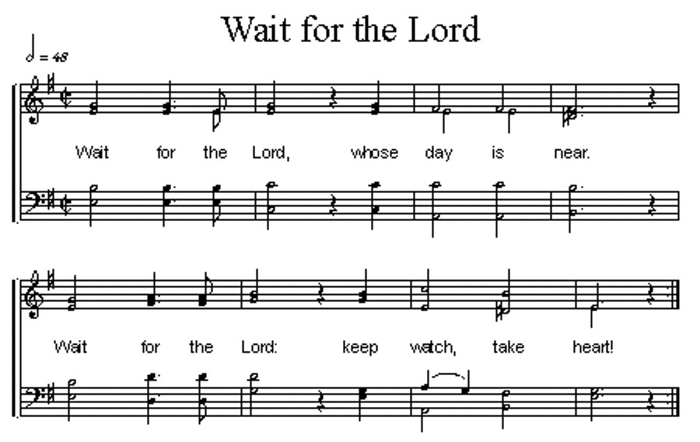

Prayers of the People/Lord’s Prayer

Our Father who art in heaven, hallowed be thy name.
Thy Kingdom come, thy will be done, on earth as it is in heaven.
Give us this day our daily bread;
and forgive us our debts, as we forgive our debtors;
and lead us not into temptation, but deliver us from evil.
For thine is the kingdom, and the power and the glory, forever. Amen

Hymn (369) “I’m Gonna Live So God Can Use Me”

Blessing and Sending

Postlude

We are glad you chose to spend your Sunday morning with us, and we encourage you to return!

Elders & Deacons will have a retreat on January 24, in the Youth Room from 10:00-noon.

Children of all ages are welcome in worship. Children’s worship materials are available from the book cart. A Cry Room is located at the back of the sanctuary.

The Deacon’s Mission Giving Project for January is Nebraska Children’s Home Society (NCHS). It is a statewide private, licensed non-profit agency focused on providing safe and loving care to children of all ages.

Birthdays

Al Beckmann 1/15
Tyler Wells 1/17
Buster Beckenhauer Jr. 1/18
Mark Johnson 1/19
Claire Sintek 1/21
Kaci Zarek 1/23

Anniversaries

Dave & Linda Unkel 1/13

Prayers for God’s Children

For healing and pain relief for those living with physical and emotional pain and for their families and friends
For our members who are home-bound or in nursing facilities
For our mission partners
For the men and women serving in our armed force

This Week at First Pres
Today: 10:00 AM – Worship
7:00 PM – 10:00 PM N/A (fellowship hall)
Monday: 8:30 AM – 10:30 AM N/A (fellowship hall)
7:00 PM – Deacons
Tuesday: 8:00 PM – 9:30 PM N/A (fellowship hall)
Wednesday: 2:00 PM – Bulletin Information Deadline
6:45 PM – Choir Rehearsal
Saturday: 8:30 AM – 10:00 AM The Link

Next Sunday
10:00 AM – Worship
10:00 AM – Good Morning, Good News

Elders Deacons
Class of 2025 Class of 2025
Teri Wendel, Christian Ed. Shelley Dahl, Secretary
Dave Gerharter, Finance Sonja Jones, Co-Moderator
Pat McCollough, Properties Mary Osborne, Co-Moderator
Class of 2026 Class of 2026
Dennis Sateren, Missions Doug Kuper
Barb Beckmann Worship/Cong. Kathy Sateren
Erin Beckenhauer, Worship/Cong.
Class of 2027 Class of 2027
Marci Pierce, Personnel Sherry Johnson, Treasurer
Sue May
Dave Unkel

Renée McClymont, Clerk of Session, Class of 2026

Elders of the Month – Renée McClymont & Marci Pierce

2025 YTD Financials – through November 30th, 2025
Receipts $188,066.18 – Disbursements $223,035.36 = Net <$34,969.18>
Last Sunday Attendance 41

Worship Leaders & Staff

PASTOR Rev. Brian Johnson
MUSIC DIRECTOR Greta Johnson ORGANIST Steve Reinke
SOUND TEAM Joe Mtika, Barb Beckmann, Jeff May
PRAISE TEAM Kim Rusk, Brynn Rusk, Joe Mtika
LAY READER Shelley Dahl

Credits: “Amazing Grace – My Chains are Gone” by Chris Tomlin
is used under CCLI license #1820283

Office hours: 9 am to 1 pm Mon.
9 am to 4 pm Tues. – Thur.
9 am to 1 pm Fri.
or other times by appointment

E-Mail: Karen@firstpresnorfolk.com
Website: firstpresnorfolk.com

Lord Jesus Christ, Our Lord Most Dear
Lord Jesus Christ, our Lord most dear,
As You were once an infant here,
So give us children of Yours, we pray,
Your grace and blessing day by day.



