First Presbyterian Church

104 So. 10th St., Norfolk, NE 68701
Phone: 402-371-1635

November 30, 2025



Mission Statement

Proclaiming the Love of Christ
in the Heart of Norfolk
Since 1896
Order of Worship
Sunday Worship, November 30, 2025
First Sunday of Advent
First PC, Norfolk, NE

Leader: The grace of the Lord Jesus Christ be with you all.
People: And also with you.

Welcome and Announcements

Passing of the Peace
Leader: The peace of the Lord Jesus Christ be with you all!
People: And also with you.

Call to Worship

Leader: I rejoiced with those who said to me, “Let us go to
the house of the Lord.”
People: Our feet are standing in your gates, O
Jerusalem.
Leader: Pray for the peace of Jerusalem:
People: May those who love you be secure.
Leader: May there be peace within your walls
People: and security within your citadels.
Leader: For the sake of my brothers and sisters,
People: I will say, “Peace be within you.”
-- Psalm 122: 1-2, 6-8

Lighting of the Advent Candle – “Waiting”
Prayer Ed & Renée McClymont

Opening Song (video) “Give Thanks”
Call to Confession

Remember that our Lord Jesus can sympathize with us in our weaknesses, since in every respect he was tempted as we are, yet without sin. Let us then with boldness approach the throne of grace, that we may receive mercy and find grace to help in time of need. Let us confess our sins against God and our neighbor.

Prayer of Confession

God of the future, you are coming in power to bring all nations under your rule. We confess that we have not expected your kingdom, for we live casual lives, ignoring your promised judgment. We accept lies as truth, exploit neighbors, abuse the earth, and refuse your justice and peace. In your mercy, forgive us. Grant us wisdom to welcome your way, and to seek things that endure when Christ comes to judge the world.

(We observe a time of silence for personal confession.)

Assurance of Pardon

Leader: Friends, hear the Good News! God has given you
grace and peace in Christ Jesus,
People: and enriched us with many good gifts.
Leader: Friends, believe the Good News!
People: In Jesus Christ, we are forgiven.

Response (579) “Glory to the Father (Gloria Patri)”

Choir Anthem “Candle of Peace”
(back page of bulletin)

The Word

Scripture Isaiah 2:1-5
Message “Waiting for Peace” Pastor Brian

Song of Response (2)
“Come, Thou Long Expected Jesus!”

Offering our Gifts

Offertory
Response (592) “Praise God, from Whom All Blessings Flow”
(Doxology)

Song of Preparation (insert)
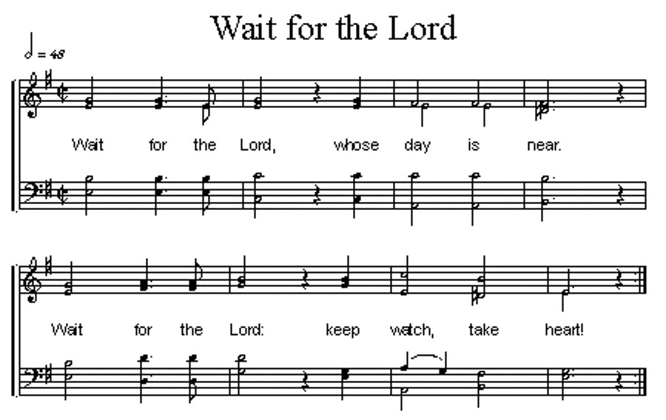

Prayers of the People/Lord’s Prayer

Our Father who art in heaven, hallowed be thy name.
Thy Kingdom come, thy will be done, on earth as it is in heaven.
Give us this day our daily bread;
and forgive us our debts, as we forgive our debtors;
and lead us not into temptation, but deliver us from evil.
For thine is the kingdom, and the power and the glory, forever. Amen

Final Song (9) “O Come, O Come, Emmanuel”

Blessing and Sending

Postlude

We are glad you chose to spend your Sunday morning with us, and we encourage you to return!

Children of all ages are welcome in worship. Children’s worship materials are available from the book cart. A Cry Room is located at the back of the sanctuary.

Hanging of the greens will be Saturday December 6th at 9am. Please mark your calendars to help!

“Warmth, Peace and Pajamas” The Salvation Army is again collecting new pajamas, mittens, socks, etc. for the pajama project. The timeframe to donate is 11/17/25-12/11/25.

We need readers for Advent!
There is a sign-up sheet in the narthex.

Blood Mobile Cookie sign-up sheet is in the Narthex for December.
The Deacon’s Mission Giving Project for November is CASA. CASA (Court Appointed Special Advocate) is a trained, citizen volunteer appointed by the Juvenile Court to ensure that the needs and interests of abused, neglected, uncontrolled or wayward children are being met. CASA’s are assigned to dependent children who are under the Juvenile Court jurisdiction and are assigned at the discretion of the Juvenile Court.

Birthdays

Evie Sintek Schroeder 11/30
Jamie Wolff 12/01
Curtis Wolff 12/09

Anniversaries
None this week

Prayers for God’s Children

For healing and pain relief for those living with physical and emotional pain and for their families and friends
For our members who are home-bound or in nursing facilities
For our mission partners
For the men and women serving in our armed force

This Week at First Pres
Today: 10:00 AM – Worship
11:15 AM – Handbell Rehearsal
7:00 PM – 10:00 PM N/A (fellowship hall)
Monday: 8:30 AM – 10:30 AM N/A (fellowship hall)
6:30 PM – Session
Tuesday: 8:00 PM – 9:30 PM N/A (fellowship hall)
Wednesday: 2:00 PM – Bulletin Information Deadline
6:45 PM – Choir Rehearsal
Saturday: 8:30 AM – 10:00 AM The Link
Next Sunday
10:00 AM – Worship

Elders Deacons
Class of 2025 Class of 2025
Teri Wendel, Christian Ed. Shelley Dahl, Secretary
Dave Gerharter, Finance Sonja Jones, Co-Moderator
Pat McCollough, Properties Mary Osborne, Co-Moderator
Class of 2026 Class of 2026
Dennis Sateren, Missions Doug Kuper
Barb Beckmann Worship/Cong. Kathy Sateren
Erin Beckenhauer, Worship/Cong.
Class of 2027 Class of 2027
Marci Pierce, Personnel Sherry Johnson, Treasurer
Sue May
Dave Unkel

Renée McClymont, Clerk of Session, Class of 2026

Elders of the Month – Erin Beckenhauer & Dave Gerharter

2025 YTD Financials – through October 31st, 2025
Receipts $163,177.10 – Disbursements $212,927.69 = Net <$49,750.59>
Last Sunday Attendance 64

Worship Leaders & Staff

PASTOR Rev. Brian Johnson
MUSIC DIRECTOR Greta Johnson ORGANIST Steve Reinke
SOUND TEAM Joe Mtika, Barb Beckmann, Jeff May
PRAISE TEAM Kim Rusk, Brynn Rusk, Joe Mtika
LAY READER Linda Cox

Credits: “Give Thanks” by Don Moen
is used under CCLI license #1820283

Office hours: 9 am to 1 pm Mon.
9 am to 4 pm Tues. – Thur.
9 am to 1 pm Fri.
or other times by appointment

E-Mail: Karen@firstpresnorfolk.com
Website: firstpresnorfolk.com

Candle of Peace
A candle is glowing a message tonight
Of harmony, unity, love’s pure light.
The radiant vision of true charity,
A candle is shimmering: grant us peace.

Dona nobis pacem, pacem,
Dona nobis pacem.

Grant us peace.

