First Presbyterian Church

104 So. 10th St., Norfolk, NE 68701
Phone: 402-371-1635

April 14, 2024

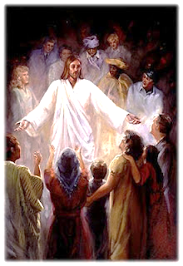

Mission Statement

Proclaiming the Love of Christ
in the Heart of Norfolk
“Since 1896”
Order of Worship
Third Sunday of Easter
April 14, 2024
First PC, Norfolk, NE

Prelude

Leader: The grace of the Lord Jesus Christ be with you all.
People: And also with you.

Welcome and Announcements

Passing of the Peace:
Signing in American Sign Language (ASL)

Leader: The peace of the Lord Jesus Christ be with you all.
People: And also with you.

Call to Worship
Leader: I waited patiently for the Lord;
People: he turned to me and heard my cry.
Leader: He lifted me out of the slimy pit, out of the mud and
mire;
People: he set my feet on a rock and gave me a place to
stand.
Leader: He put a new song in my mouth, a hymn of praise to
our God.
People: Many will see and fear and put their trust in the
Lord.
Leader: Blessed are those who make the Lord their trust,
who do not look to the proud,
People: to those who turn aside to false gods.
Leader: Many, O Lord my God, are the wonders you have
done.
People: The things you planned for us no one can
recount to you;

Leader: were I to speak and tell of them,
People: they would be too many to declare.
-- Psalm 40:1-5

Opening Hymn (485) “To God Be the Glory”

Call to Confession

The proof of God’s amazing love is this: While we were sinners Christ died for us. Because we have faith in him, we dare to approach God with confidence. In faith and penitence, let us confess our sin before God and one another.
Prayer of Confession

Almighty God, in raising Jesus from the grave, you shattered the power of sin and death. We confess that we remain captive to doubt and fear, bound by the ways that lead to death. We overlook the poor and the hungry, and pass by those who mourn; we are deaf to the cries of the oppressed, and indifferent to calls for peace; we despise the weak, and abuse the earth you made. Forgive us, God of mercy. Help us to trust your power to change our lives and make us new, that we may know the joy of life abundant given in Jesus Christ, the risen Lord.

(We observe a time of silence for personal confession.)

Assurance of Pardon

Leader: Friends, hear the Good News! Through Jesus
Christ, we are made able to plead our case to God.
People: Jesus Christ is just and the remedy for the
defilement that is our sin; even more, the sins
of the whole world.
Leader: Friends, believe the Good News!
People: In Jesus Christ, we are forgiven.
Response (579) “Glory to the Father (Gloria Patri)”

Choir Anthem “His Unconditional Love”
(back page of bulletin)
The Word
Scripture: Luke 24:36b-48
Sermon: “No Fear ” Pastor Brian

Hymn of Response (video)
“Open the Eyes of My Heart, Lord”
Offering our Gifts

Response (592) “Praise God, from Whom All Blessings Flow”
(Doxology)

Call to Prayer
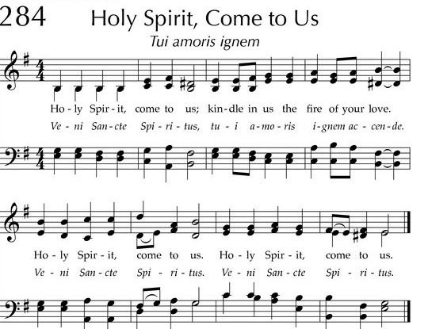

Prayers of the People/ Lord’s Prayer

Our Father who art in heaven, hallowed be thy name.
Thy Kingdom come, thy will be done, on earth as it is in heaven.
Give us this day our daily bread;
and forgive us our debts, as we forgive our debtors;
and lead us not into temptation, but deliver us from evil.
For thine is the kingdom, and the power and the glory, forever.

Final Hymn (442) “The Church’s One Foundation”

Blessing and Sending

Postlude

We are glad you chose to spend your Sunday morning with us, and we encourage you to return!

Children of all ages are welcome in worship. Children’s worship materials are available from the book cart. A Cry Room is located at the back of the sanctuary.

Worship and Cong. Life committees express our GRATITUDE to all who participated to make our Lenten/Easter/Holy Week season so meaningful.
This includes the book study group, adorning the sanctuary and entry with the palm fronds and holders, crosses, drapings and wreaths, and the beautiful Easter lilies. Also, Maundy Thursday supper and worship, Good Friday open prayer and meditation time, communion set-ups, meaningful music and homilies. We celebrate our risen Lord and our fellowship as part of the family of His believers.

Food Pantry. May is the month for FPC to serve the Food Pantry. A sign-up sheet is in the narthex. Three volunteers are needed each day. Please give prayerful thought to fulfilling our mission. Thank You!
Deacons Project for April is The Orphan Grain Train. In loving response to Christ, the Servant, the Orphan Grain Train encourages and enables God’s people to share personal and material resources to needy people both far and near. Grain Train volunteers gather donations of clothing, medical supplies, food and other aid to meet real needs. 97% of all monies go directly to missions, with only 3% used for overhead expenses.

Birthdays

Ruth Anderson 4/14
Mark Losse 4/18
Andrew Praeuner 4/19
Richard Kautzman 4/20
Greta Johnson 4/23
Jabin Sateren 4/24

Anniversaries

None this week

Prayers for God’s Children

For healing and pain relief for those living with physical and emotional pain and for their families and friends

For our members who are home-bound or in nursing facilities

For our mission partners
For the men and women serving in our armed forces

This Week at First Pres
Today: 10:00 AM – Worship
11:00 PM – N/A (fellowship hall)
Monday: 8:30 AM – 10:00 AM N/A (fellowship hall)
Tuesday: 8:00 PM – 9:30 PM N/A (fellowship hall)
Wednesday: 2:00 PM – Bulletin Information Deadline
6:45 PM – Choir Rehearsal
Thursday: 5:30 PM – 7:00 PM TOPS (fellowship hall)

Next Sunday at First Pres
10:00 AM – Worship
10:00 AM – Good Morning, Good News
1:00 PM – 5:00 PM Kindermusik Program (sanctuary/narthex)

Elders Deacons
Class of 2024 Class of 2024
Linda Cox, Personnel Mark Johnson, Moderator
Kathy Naranjo, Worship/Cong. Sherry Johnson, Treasurer
Jayne Mtika
Class of 2025 Class of 2025
Teri Wendel, Christian Ed. Shelley Dahl, Secretary
Dave Gerharter, Finance Joyce Zittritsch
Pat McCollough, Properties Sonja Jones
Class of 2026 Class of 2026
Dennis Sateren, Missions Doug Kuper
Barb Beckmann, Worship/Cong. Kathy Sateren
Erin Beckenhauer
Renee, McClymont, Clerk of Session

Elders of the Month – Dennis Sateren & Teri Wendel

2024 YTD Financials – through February 29th, 2024
Receipts $38,728.57 – Disbursements $34,777.46 = Net $3,951.11
Last Sunday Attendance 46

Worship Leaders & Staff
PASTOR Rev. Brian Johnson
MUSIC DIRECTOR Greta Johnson ORGANIST Steve Reinke
SOUND TEAM Joe Mtika, Barb Beckmann
PRAISE TEAM Kim Rusk, Brynn Rusk, Joe Mtika
LAY READER Barb Beckmann

Credits: “Open the Eyes of My Heart, Lord” by Paul Baloche
is used under CCLI license #1820283.

Office hours: 9 am to 1 pm Mon.
9 am to 4 pm Tues. – Thur.
9 am to 1 pm Fri.
or other times by appointment

E-Mail: FirstPresB@ConPoint.com
Website: firstpresnorfolk.com
‘Like’ us on Facebook: First Pres – Norfolk, NE

His Unconditional Love
What would cause a King to leave His throne,
To travel from his Father’s side and with the poorest folks abide?
Why would He want us for His own
When we had turned our backs on Him and chose instead a life of sin?

It was His unconditional love,
Unconditional love that made Him leave His father’s home,
Made Him leave His heav’nly throne to die on Calvary
For sinners just like me.
I’m so thankful for His unconditional love!

Would He not spare His holy Son,
When long before the world began, He knew the sinful heart of man?
We are so unworthy of His love!
What made Him open Heaven’s door so we might live forevermore?

(chorus)

He only asked for one thing in return –
No favors, no hidden strings;
He only asked for this one thing;
That we would serve Him all our days, and offer Him the highest praise.
I’m so thankful for His unconditional love!
(chorus)

